# Portfolio Milestone 2

**Steps**:

* Define ShoppingCart Class with attributes customer name, current date, cart items list(Zybooks,2019).
* Define parameterized constructor with default constructor(GeeksforGeek,2023).

class ShoppingCart:

customer_name : str

current_date : str

cart_items = []

# Default Constructor to initialize customer name and date

def __init__(self, name='none', date = 'January 1,2020'):

self.customer_name = name

self.current_date = date

* Create Method for add items, Modify items, Remove items.
  + Add Items Method : Has parameter - itemToPurchase

Append item to Cart Item List (GeeksforGeek,2023).

def add_item(self,temp_item):

self.cart_items.append(temp_item)

* + Modify Item Method: Modifies an item's description, price, and/or quantity.

Has parameter - ItemToPurchase. If an item is present in the cart, the parameter doesn’t have a default value. modify the item in the cart. If an item is not present in the cart, it shows a message - Item not found in cart (Zybooks,2019).

**Logic** - Since it is a List object, the program uses index to perform action on the cart items list. Here, ‘for loop’ will run for a range from 0 to length of cart_items List.

The program compares if specific values from user input is default value and only updates the record if it’s not default.

It sets flag item_found to true and breaks the loop (as we already found the value, no need to run the loop again. **Assumption** - only one unique record with the same item name.) If an item is not found in the cart, it shows output: Item not found in cart.

def modify_item(self,temp_item):

for i in range(len(self.cart_items)):

if self.cart_items[i].item_name == temp_item.item_name:

if( int(temp_item.item_price) != 0):

self.cart_items[i].item_price = temp_item.item_price

if( temp_item.item_quantity != 0):

self.cart_items[i].item_quantity = temp_item.item_quantity

if( temp_item.description != ''):

self.cart_items[i].description = temp_item.description

#shopping_cart.cart_items.update(temp_item)

item_found = True

break

if(not item_found):

print('Item not found in cart.')

* + Remove item Method : Has Parameter - String: item_name

It runs the loop for cart_items list, searches the item with attribute item_name as parameter. Remove the indexed element using the del method (GeekforGeeks,2023). If no records are found, it shows a message that Item is not found.

def remove_item(self,rmv_item):

for i in range(len(self.cart_items)):

if self.cart_items[i].item_name == rmv_item:

del self.cart_items[i]

item_found= True

break

if(not item_found):

print('Item not found in cart.')

* + Method - get_num_items_in_cart : Doesn’t accept any parameter.

It loops through all cart_items and adds quantities of items within the list and returns the count.

def get_num_items_in_cart(self):

total_count = 0

for item in self.cart_items:

total_count += item.item_quantity

return total_count

An Alternative method to calculate total is using the sum function.

total_count = sum(i.quantity for i in self.cart_items) (Built-in Types, n.d.-c)

* + Method - get_cost_of_cart : Doesn’t accept any parameter.

Iterate through all cart_items, calculate the total cost of items within the cart and return the Total Cost (Zybooks,2019).

for item in self.cart_items:

Total_Cost += (item.item_price * item.item_quantity)

return Total_Cost

* + Method - print_total : Doesn’t accept any parameter. Calls get_cost_of_cart to get total cost of cart items. Calls ItemtoPurchase’s print_item_cost to print each item. Format the output (Zybooks, 2019).

print(shopping_cart.customer_name,'\' Shopping Cart -', self.current_date)

if self.cart_items:

print('\tNumber of Items:', self.get_num_items_in_cart())

for item in shopping_cart.cart_items:

item.print_item_cost()

print('\n\tTotal:', '${:.2f}'.format(total_cart_Cost))

print('==============================')

print('Thank you for shopping with us!\n')

else:

print('SHOPPING CART IS EMPTY.')

* + Method - print_item_description: No parameters. If there are items in the cart, get the description of each item by iterating them (GeekforGeeks,2023).

if self.cart_items:

print('\tItem Descriptions')

for item in self.cart_items:

print(item.item_name, ':', item.description)

else:

print('SHOPPING CART IS EMPTY.')

**Step: 5**

* **Print Menu**:

Define method print_menu. Accepts parameter as shopping_cart object. It prints menu options for users to view and select (Zybooks,2019).

def print_menu(obj_cart):

print('\t\tMENU\n')

print('\ta - Add item to cart')

print('\tr - Remove item from cart')

print('\tc - Change item quantity')

print('\ti - Output items \'descriptions\'')

print('\to - Output shopping cart')

print('\tq - Quit')

print('\t\tChoose an option:\n')

* **Main** -
  + Program creates shopping cart object (default/based on user input)
  + It runs Do_while loop setting limit of Max_ITEM to avoid infinite loop (Python, 2022).
  + It calls print_menu() and prints Menu for User to insert the selected option.
  + Implement quit option to make sure, this while loop doesn’t go into infinite loop while testing locally. It will capture user input and as soon it receives ‘q’, it will break the loop and exit (Python, 2022).
  + Based on User’s input, it calls specific methods defined earlier. Here, for the add and modify option, it prompts the user to insert values and stores the data into ItemToPurchase object and passes that as a parameter to the appropriate method (Gaddis, 2017).
  + If a user inserts invalid options, the program will prompt the user to enter a valid option.
* MAX_ITEM = 10
* item_count = 0
* if(c_name and c_date):
* shopping_cart = ShoppingCart(c_name,c_date)
* else:
* shopping_cart = ShoppingCart()
* while (item_count< MAX_ITEM):
* print_menu(shopping_cart)
* user_input = input().lower()
* if user_input == 'a':
* temp_item = ItemToPurchase()
* # assign user input value via attribute assignment
* try:
* temp_item.item_name = input('Enter Item Name: \n')
* temp_item.description = input('Enter Description:\n')
* temp_item.item_price = float(input('Enter Item Price: \n'))
* temp_item.item_quantity = int(input('Enter Item Quantity: \n'))
* shopping_cart.add_item(temp_item)
* item_count += 1
* except:
* print('Invalid Input.')
* elif user_input == 'r':
* rm_item = input('Please Enter Item Name to Remove.')
* shopping_cart.remove_item(rm_item)
* elif user_input == 'c':
* temp_item = ItemToPurchase()
* # assign user input value via attribute assignment
* try:
* temp_item.item_name = input('Enter Item Name to update: \n')
* temp_item.description = input('Enter Description to update: \n')
* temp_item.item_price = float(input('Enter Item Price to update: \n'))
* temp_item.item_quantity = int(input('Enter Item Quantity to update: \n'))
* except:
* print('Invalid Input.')
* shopping_cart.modify_item(temp_item)
* elif user_input == 'i':
* print('\tOUTPUT ITEMS\' DESCRIPTIONS')
* shopping_cart.print_descriptions()
* elif user_input == 'o':
* print('\tOUTPUT SHOPPING CART')
* shopping_cart.print_total()
* elif user_input == 'q':
* print('You have selected to Exit.')
* print('Thank you for shopping with us!\n')
* break
* else:
* print('Please select valid input or press q to Quit.')

**Step 6:** Implement Output shopping cart menu option. Implement Output item's description menu option.

* **Output Shopping Cart** - The user selects option - ‘o’ from the menu by typing o or O.
  + The user input is converted to lower and compared for the conditions.

user_input = input().lower()

* + Calls the method print_total()

elif user_input == 'o':

print('\tOUTPUT SHOPPING CART')

shopping_cart.print_total()

* + Print_total calls get_cost_of_cart method to get total Cart value.
  + If there are items in the list then, Program iterates over the list and call

print_item_cost() to print the individual item and the cost of each item.

* + Format the total_cost via string formatter and print the value.
  + Prints User Friendly output format (Zybooks, 2019) (Section - Method - print_total).
  + If the cart is empty then it displays a message that ‘SHOPPING CART IS EMPTY.’
* **Output item's description**: The user selects option - ‘i’ from the menu by typing i or I.
  + If there are items in the cart, get the description of each item by iterating them (GeekforGeeks,2023).

if self.cart_items:

print('\tItem Descriptions')

for item in self.cart_items:

print(item.item_name, ':', item.description)

else:

print('SHOPPING CART IS EMPTY.')

**Note**: Add, modify and remove are implemented here. I realized that the detailed implementation is part of the Capstone Project. I had not noticed it earlier, so I have included it here.

However, In reality, the add, modify and remove method would be a stub method which can display ‘Under Construction… Coming Soon.’

**Output**: Screenshot - Print Menu

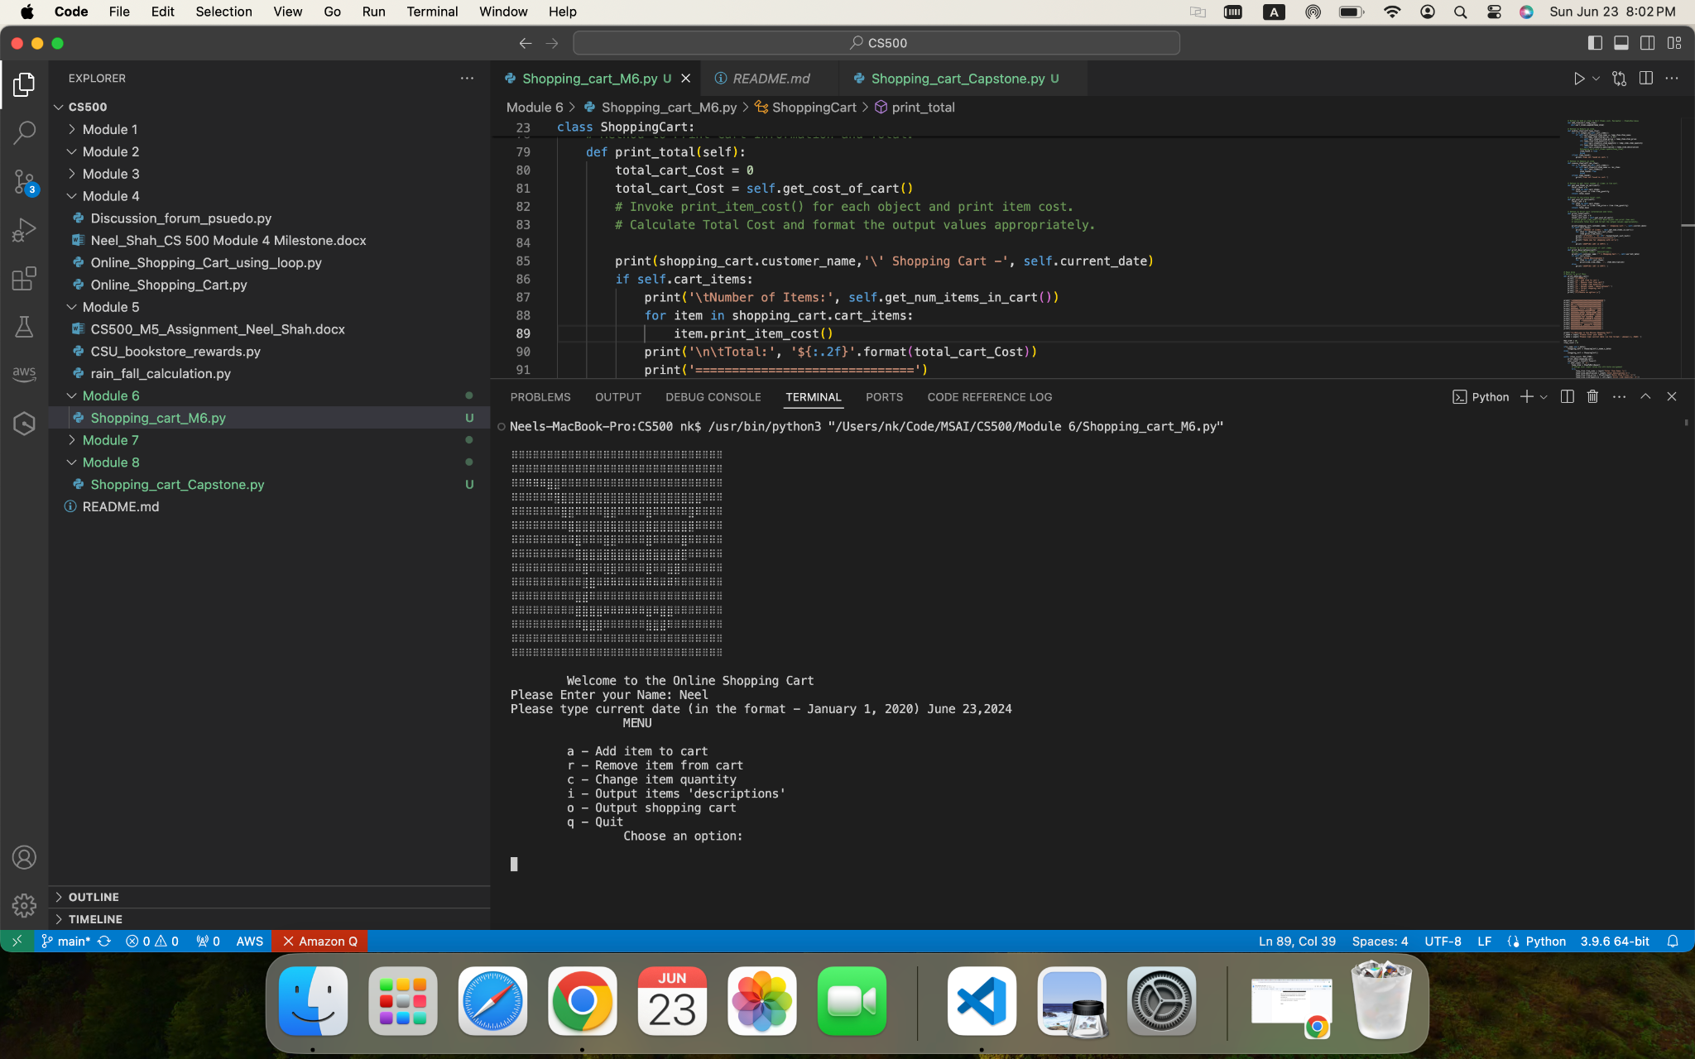

Screenshot - Selecting Quit Option

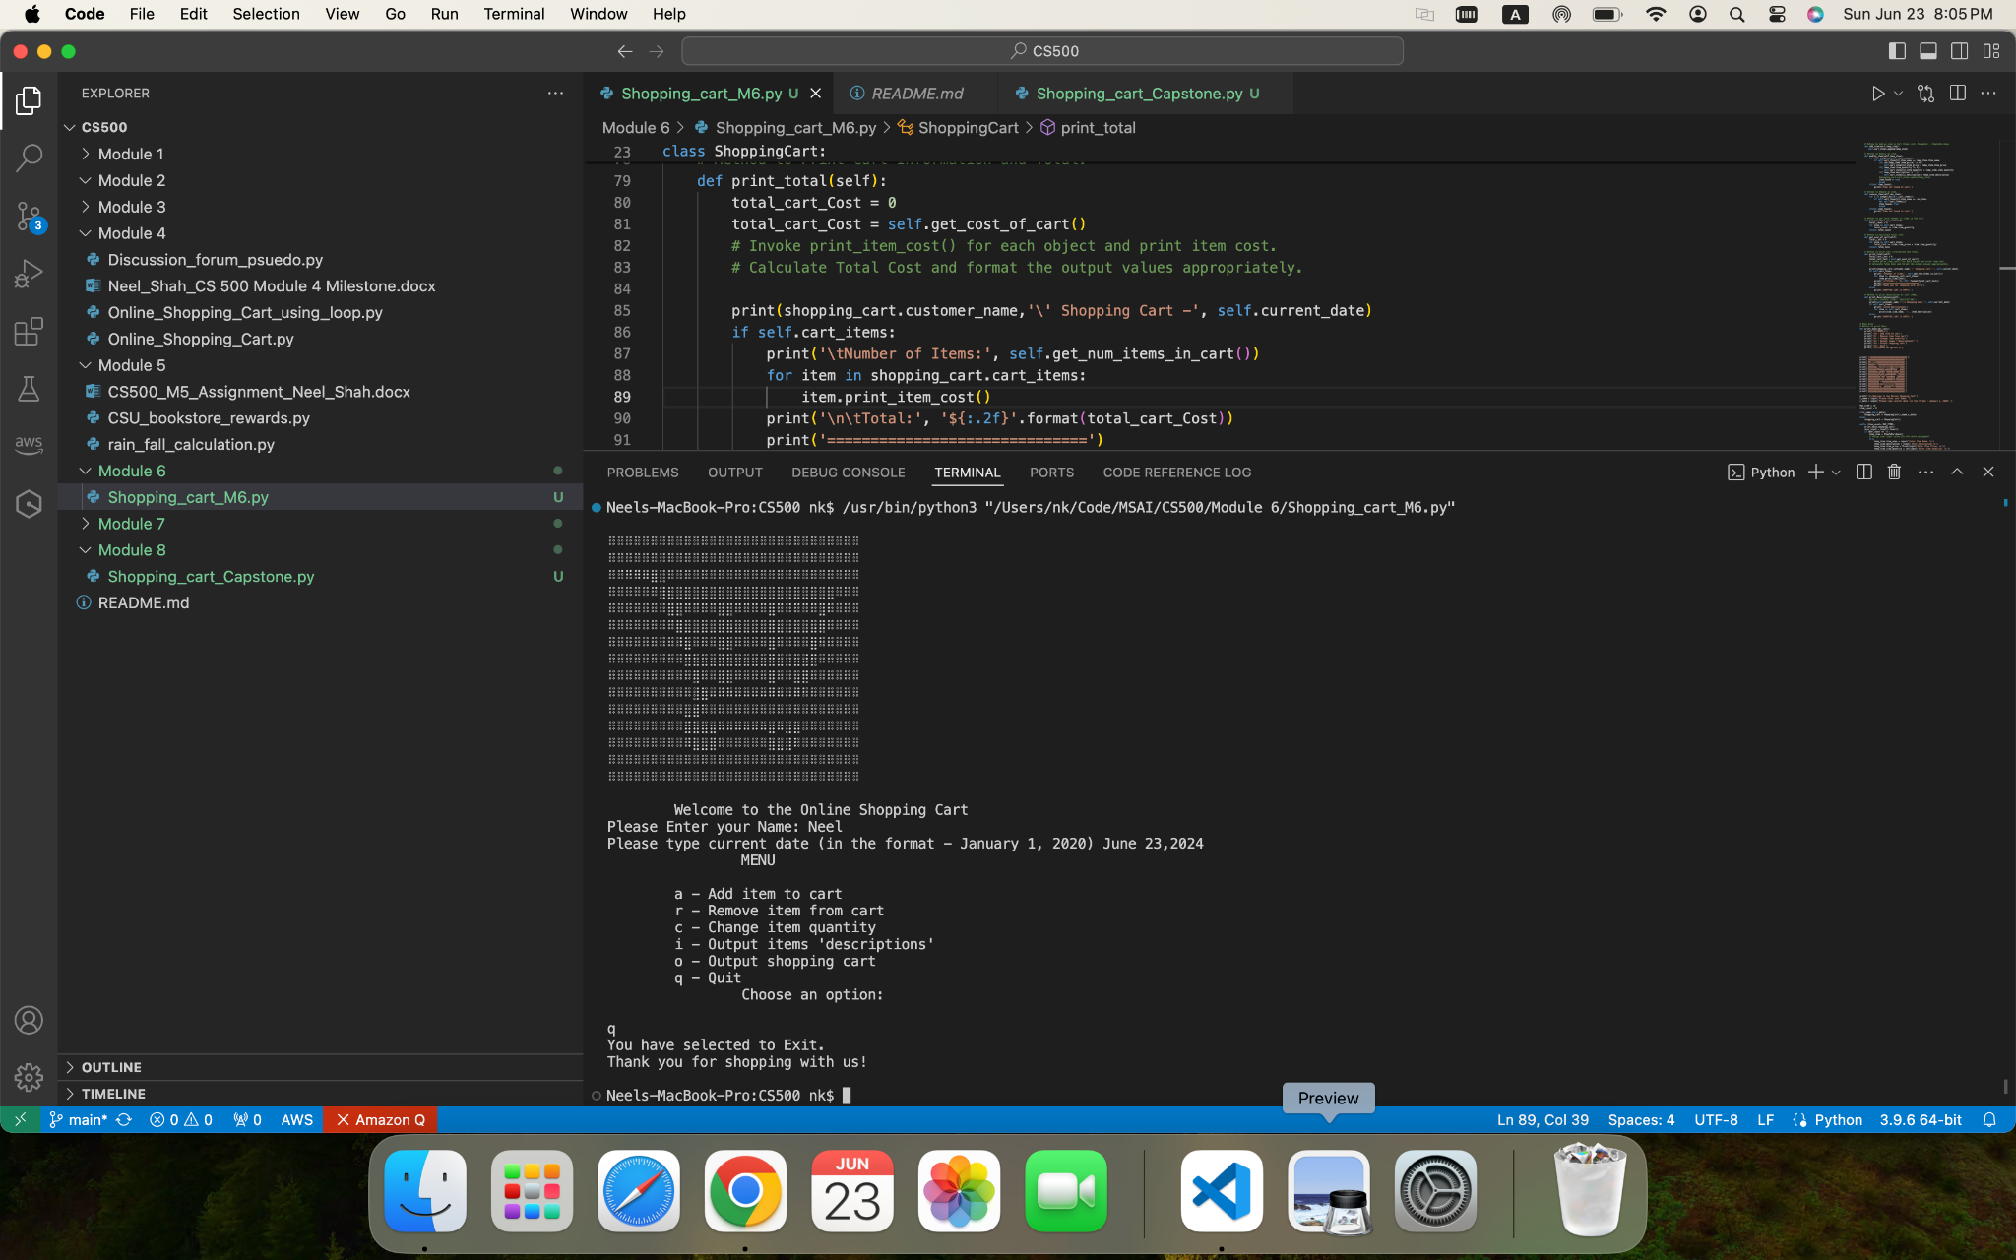

Screenshot - Selecting Output Shopping Cart Option

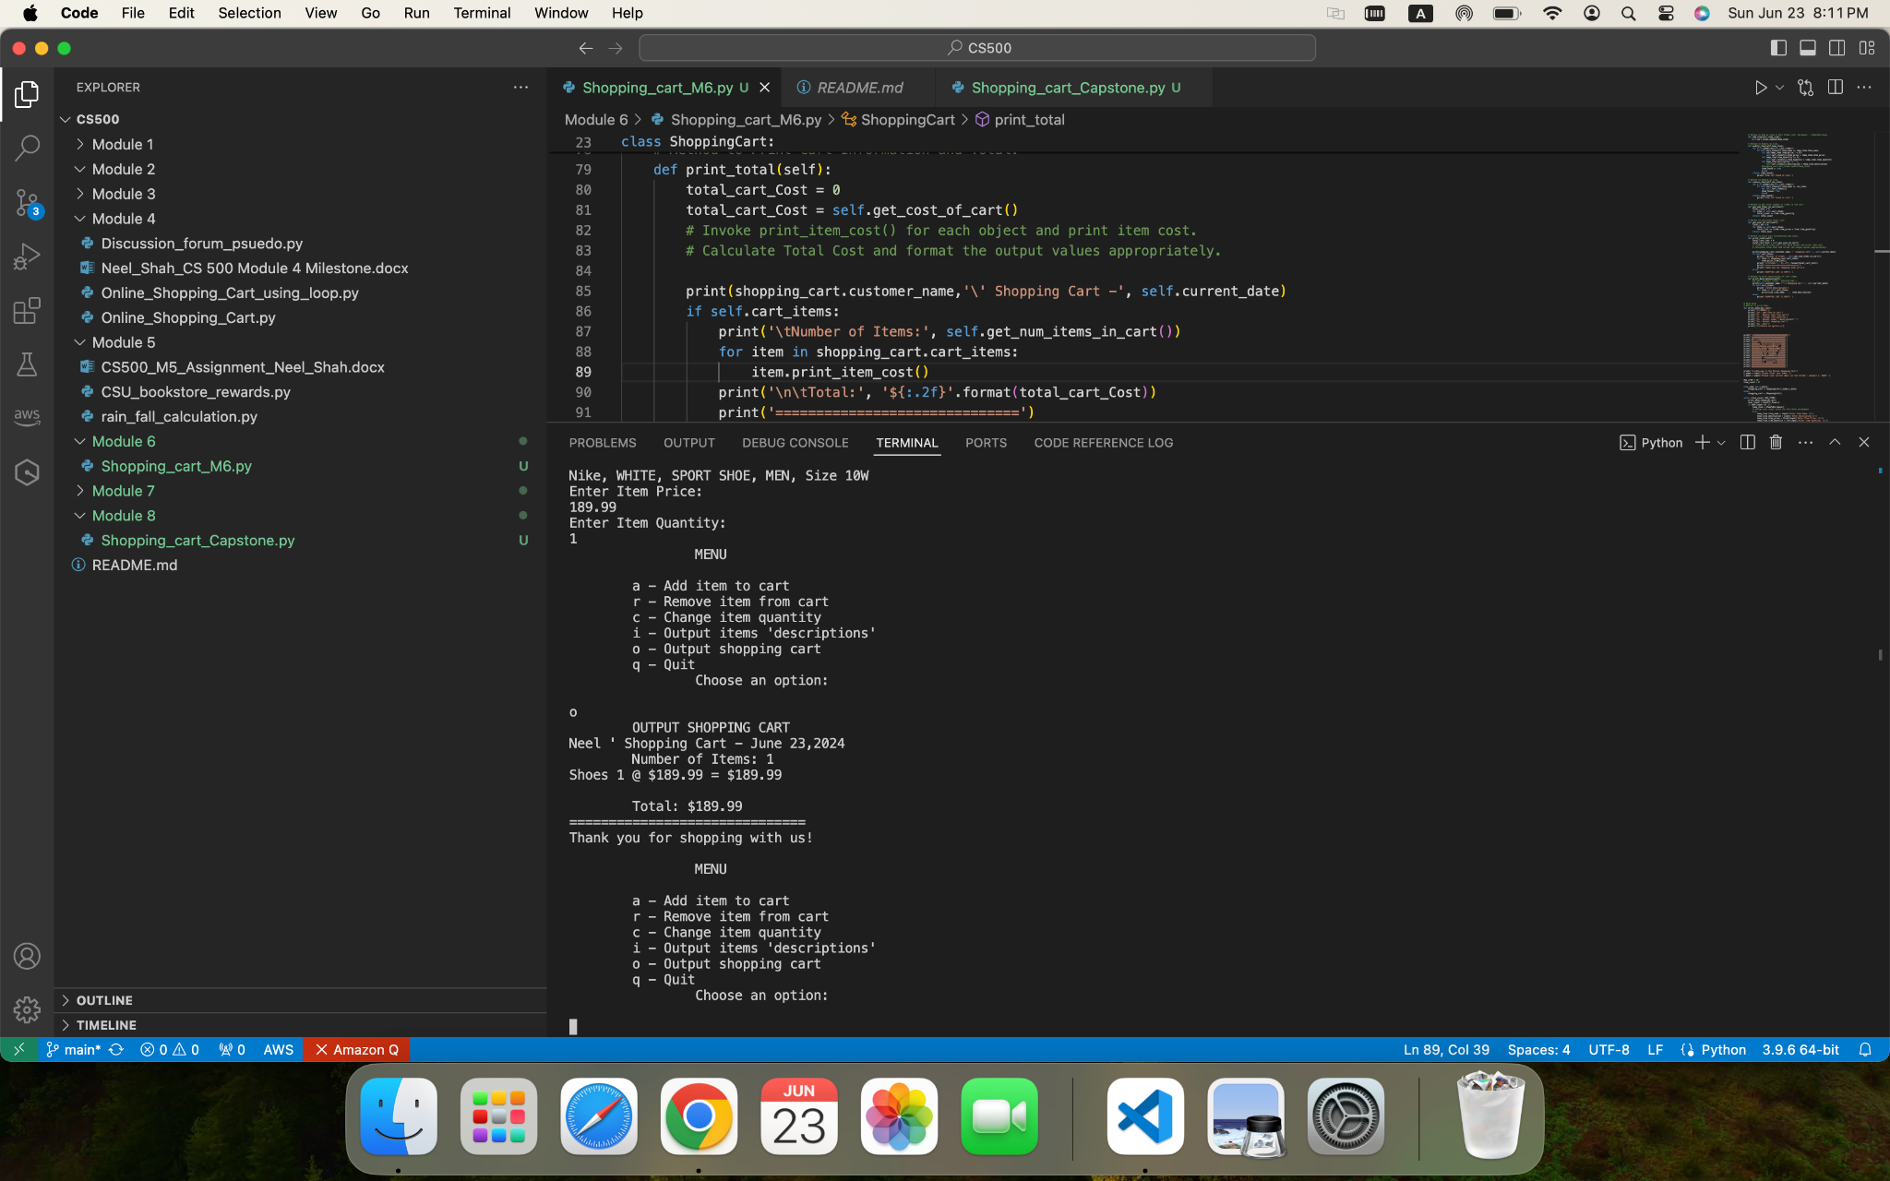

Screenshot - Output Items ‘descriptions’

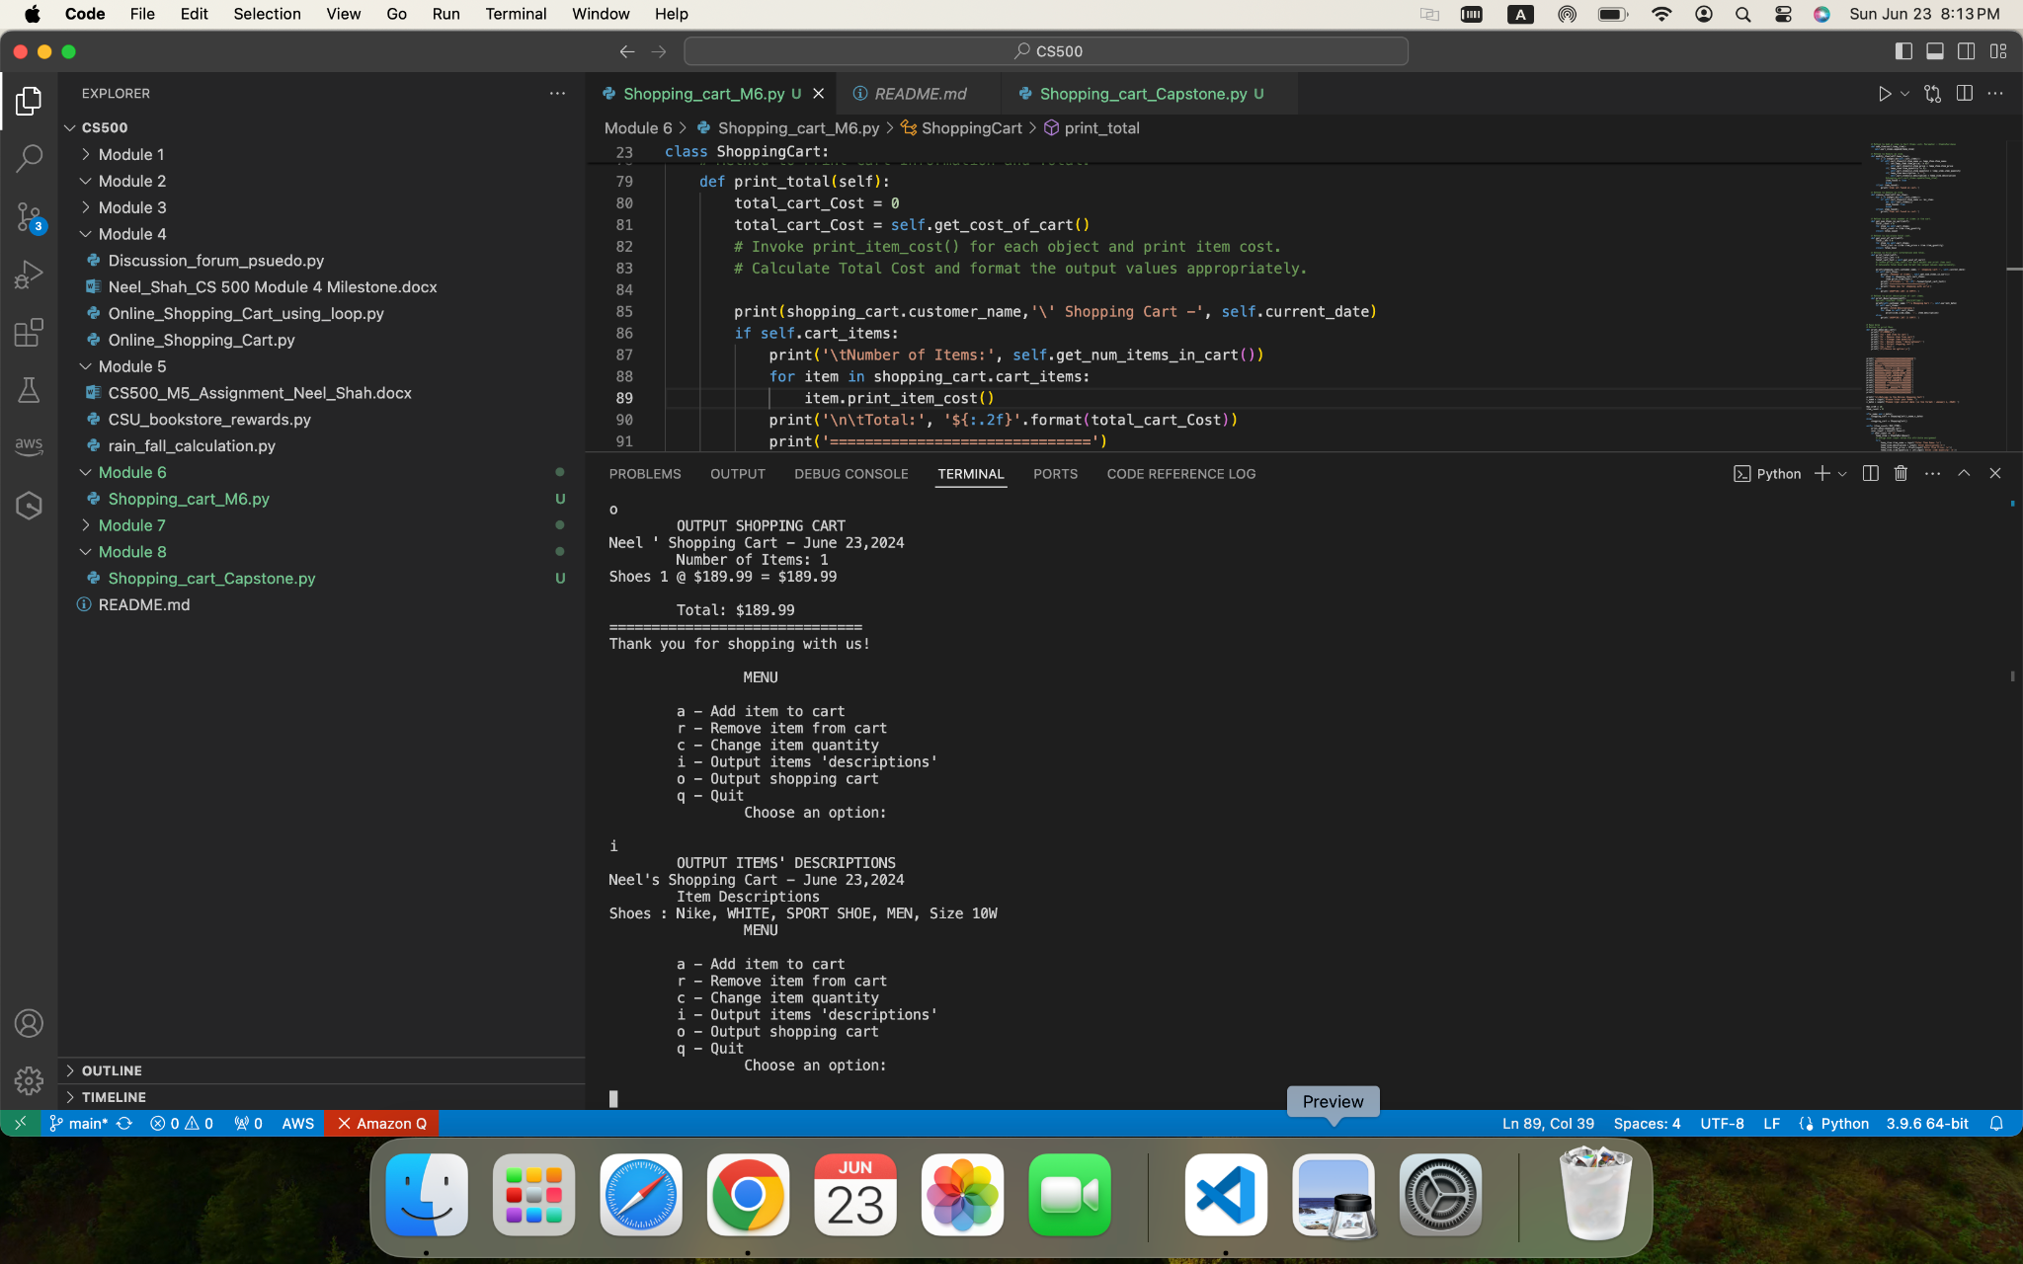

**Source Code Path:**

<https://github.com/nshahcsu/MSAI/blob/main/CS500/Module%206/Shopping_cart_M6.py>

**References:**

Built-in types. (n.d.-c). Python Documentation. https://docs.python.org/3/library/stdtypes.html#lists

Gaddis, T. (2017). Starting Out with Python (4th Edition).

GeeksforGeeks. (2023, March 1). *Constructors in Python*. GeeksforGeeks. https://www.geeksforgeeks.org/constructors-in-python/

GeeksforGeeks. (2024, April 5). Python Functions. GeeksforGeeks. <https://www.geeksforgeeks.org/python-functions/>

GeeksforGeeks. (2023b, April 7). Python Remove elements at Indices in List. GeeksforGeeks. https://www.geeksforgeeks.org/python-remove-elements-at-indices-in-list/#

GeeksforGeeks. (2023, April 13). Python try except. GeeksforGeeks. https://www.geeksforgeeks.org/python-try-except/

Python, R. (2022, July 18). Python “while” Loops (Indefinite Iteration). https://realpython.com/python-while-loop/

ZyBooks. (2019 August). CSC500: Principles of Programming. Module 2.19.